***Question I: What did you do/accomplish?***

As international students, our group strives to help new incoming international students, especially graduate students and visiting scholars. We assume it could be a number of important tips that relate to our everyday life on MSU campus. Besides, it could be some regular issues we encounter due to our international students’ statuses, or could be some suggestions when new students face situations that differ from their background, culture, and life experiences. With a lot of discussion in our group, we have decided to design a guide book which may provide useful and clear information to incoming international students of all levels. Based on the discussions, the rationale behind the Guide Book and brainstormed points, some problems, issues, possible challenges that might be real for new international students, especially graduate students and visiting scholars are the following:

Easily Navigate Campus Life

Identify Resources for International Students

Stay Safe

Get Involved in Campus Activities Beyond Academics

Get Work and Training Experiences

Choose the Right Place or Office to Address a potential problem

The points, problems, and issues listed are mostly based on our own experiences and what we consider as the great importance. Afterwards, we have realized that our personal experience was not enough and not universal to most new graduate students and visiting scholars. Fortunately, Chinese students in our group have had guiding brochures from Chinese student organizations that were designed long ago. We have looked through and highlighted the points made in the new version of brochure and got the idea of how to manage the content of our group’s Guide Book. We have chosen the points that are universal for all international students, limited to graduate school life, and remain as cores. We have focused on some aspects that we find more useful for graduate students and visiting scholars from previous brochure. Moreover, we have added some notices and content from MSU website into those aspects. We have agreed that some pictures of campus may help students to get exposed to the spots on campus before they arrived at MSU. Besides, we are going to use photos of campus that made by ourselves as the background of our guide book. We target at not only to demonstrate the beauty of the background but also to use them as a good introduction of campus sites.

In order to make our guide book more reliable and comprehensive, on one hand we need to check the correction with more references like university websites, on the other hand, we are planning to conduct a survey among current graduate students and visiting scholars to figure out what their thoughts are about the guide book and what ideas they may add in designing the guide book.

***Question II: What did you learn (about leadership, about yourselves, about emotional intelligence, or anything along those lines)?*** We have learned what ***Emotional Intelligence*** is. It is the ability to identify and manage one’s own emotions and the emotions of others. It includes three skills: emotional awareness; the ability to harness emotions and apply them to tasks like thinking and problem solving; and the ability to manage emotions that includes regulating one’s own emotions and cheering up or calming down others.

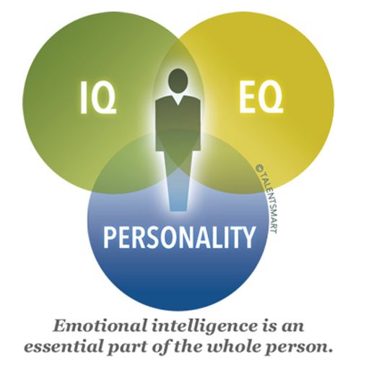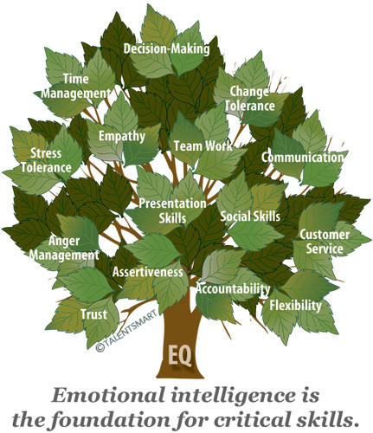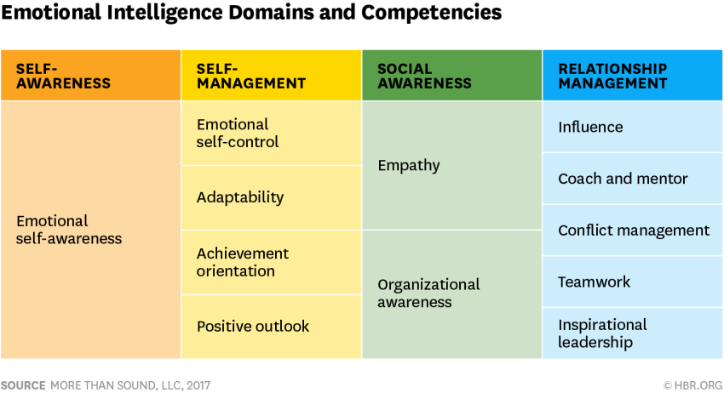

We have learned the following:

* [Recognize, understand and manage](http://www.ihhp.com/developing-emotional-intelligence)our own emotions;
* Recognize, understand and influence the emotions of others;
* It helps to better social relations including family and intimate relationships;
* Highly emotionally intelligent individuals are perceived more positively by others;
* It improves academic achievement;
* It assists in social relations during work performance and in negotiations and also in psychological well-being;

We have learned that five components of emotional intelligence allow individuals, especially the ones in leadership positions, to recognize, connect with, and learn from their own and other people’s mental states:

* Self-awareness
* Self-regulation
* Motivation that is defined as “a passion for work that goes beyond money and status”.
* Empathy for others
* Social skills, such as proficiency in managing relationships and building networks

For leadership to be conducted properly an understanding of what exactly constitutes emotional intelligence is important. It is not only because the capacity is central to leadership but because people strong in some of its elements can be utterly lacking in others, sometimes to even disastrous effect. The vivid example of this may be the leaders who are remarkable in empathy and yet so devoid of self-control. We can imagine someone who never losses his temper, no matter what problems he or she is facing. Or we might think of the leaders whose staff holds complete trust to them, listen to their team, remain easy to talk to, and constantly make careful and informed decisions.

Given that, as a leader we should manage five components of emotional intelligence and higher our emotional intelligence so that we grow as an effective leader.